**POLS 150 Spring 2023**

**Simulation Country Profile: Polsistan**

This is a profile of a fictional developing country called “Polsistan” for your state building (constitution ratification) simulation.

Present-day Polsistan is located in Central Asia, and has diverse cultural influence as a result of its history. Historically the area was ruled by Persian empire, invaded by Alexander the Great (ancient Greece), ruled by Muslim empire and Mongol empire. In medieval times, it was an important stop on the Silk Road connecting Europe and China and had a few flourishing Islamic cities. It was ruled by the British empire in the early 1800s, then annexed by the Russian empire in the late 1800s and Polsistan became a constituent republic of the Soviet Union in 1924. Polsistan achieved independence when the Soviet Union dissolved in 1991.

Extensive natural gas reserves, which have yet to be fully exploited, have begun to transform the country. The Government of Polsistan is moving to expand its extraction and delivery projects and has attempted to diversify its gas export routes to China. Half the county lives in the countryside and the rural population is engaged in agriculture. There is potential for urban industrialization, but currently lacks investment.

The county was ruled by a brutal dictator and President for Life called the Grand Professor. The Grand Professor ruled Polsistan for over 50 years. The parliament building called Great Blake Hall was a rubber stamp parliament with no legislative power to make (or even to question) polices. The Grand Professor died in February 2023 leaving Polsistan without a leader or a functioning government. New parties have been formed and the new parties plan to meet at the Great Blake Hall (the GBH) in May to create a new constitution for the government of Polsistan. The GBH is a 65 seat legislative body. The government under the Grand Professor was a unitary government and a unicameral system.

**Demographics**

Population: 5,310,000

Ethnic groups: POLS 50%, SOC 10%, ECON 10%, HIST 10%, ANTH 10%, GIST 10%

Languages: POLS is an official language, but SOC, ECON, HIST, ANTH and GIST are also spoken.

Religions: Muslim 20%, Christian 20%, Jewish 20%, Buddhist 20%, Atheist 20%

Birth rate: 19.1 births/1,000 population

Infant mortality rate: 34.3 deaths/1,000 live births

Life expectancy at birth: 70.4 years (67.3 years for males, 74.6 years for females)

Urban population: 50.8% of total population

Urbanization rate: 2.2%

Population distribution: The ethno-linguistic groups and religious groups are geographically dispersed across the country. Approximately 50% of the population lives in and around the capital of Pols City.

Age Structure:

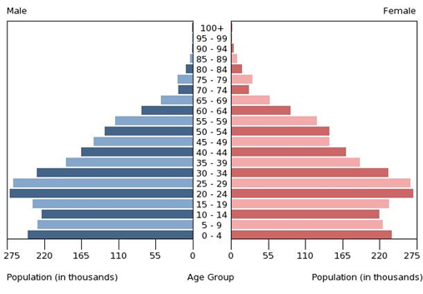

**Geography**

Location: Central Asia

Area: 468,400 sq km (slightly larger than California)

Climate: subtropical desert

Terrain: flat-to-rolling sandy desert with dunes rising to mountains in the south.

Natural resources: petroleum, natural gas, sulfur, salt

Land use: Agricultural land 72%, Forest 8.8%, Other 19.2%

Natural hazards: earthquakes, mudslides, droughts, dust storms, floods

Current environmental issues: contamination of soil and groundwater with agricultural chemicals and pesticides; salination, water logging of soil due to poor irrigation methods, desertification.

**Economy**

GDP (current US$): $40.8 billion (2022)

GDP growth rate: 6.2% (2022)

GDP per capita PPP (current int’l$) from 1990-2018:

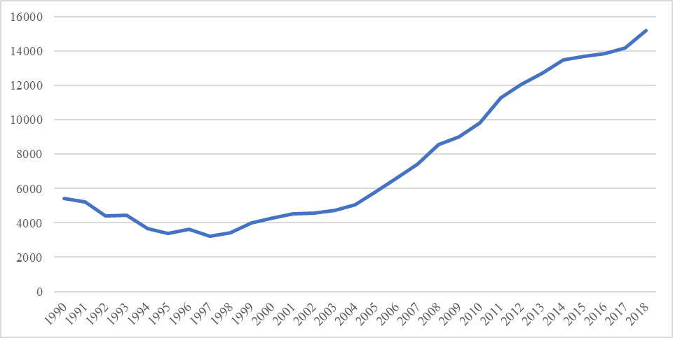

GDP composition by sector of origin: Agriculture 7.5%; Industry 44.9%; Services 47.7%

Agriculture products: Cotton, grains, melons, livestock

Industries: natural gas, oil, petroleum products, textiles, food processing

Labor force by occupation: Agriculture 48.2%; Industry 14.8%; Services 37.2%

Unemployment rate: 11%

Budget: Revenues $5.657 billion; Expenditures $6.714 billion

Exports: $7.394 billion

Exports commodities: gas, crude oil, petrochemicals, textiles, cotton fiber

Exports partners: China 70%, Turkey 5.3%, Italy 5.3%, Afghanistan 4.5%, Russia 4.1%

Imports: $4.801 billion

Imports commodities: machinery and equipment, chemicals, foodstuffs

Imports partners: Turkey 26.4%, Russia 10.5%, Japan 8.6%, Germany 8.2%, South Korea 7.8%, China 7.2%, Italy 5.2%

**Infrastructure**

Health expenditures: 4.7% of GDP

Physicians density: 2.29 physicians/1,000 population

Hospital bed density: 4 beds/1,000 population

Drinking water source: 71.1% of population (89.1% urban, 53.7% rural)

Education expenditures: 3.2% of GDP

School life expectancy: 13 years

Literacy rate: 99.7%